**The Importance of Learning Body Language for the Younger Generation**

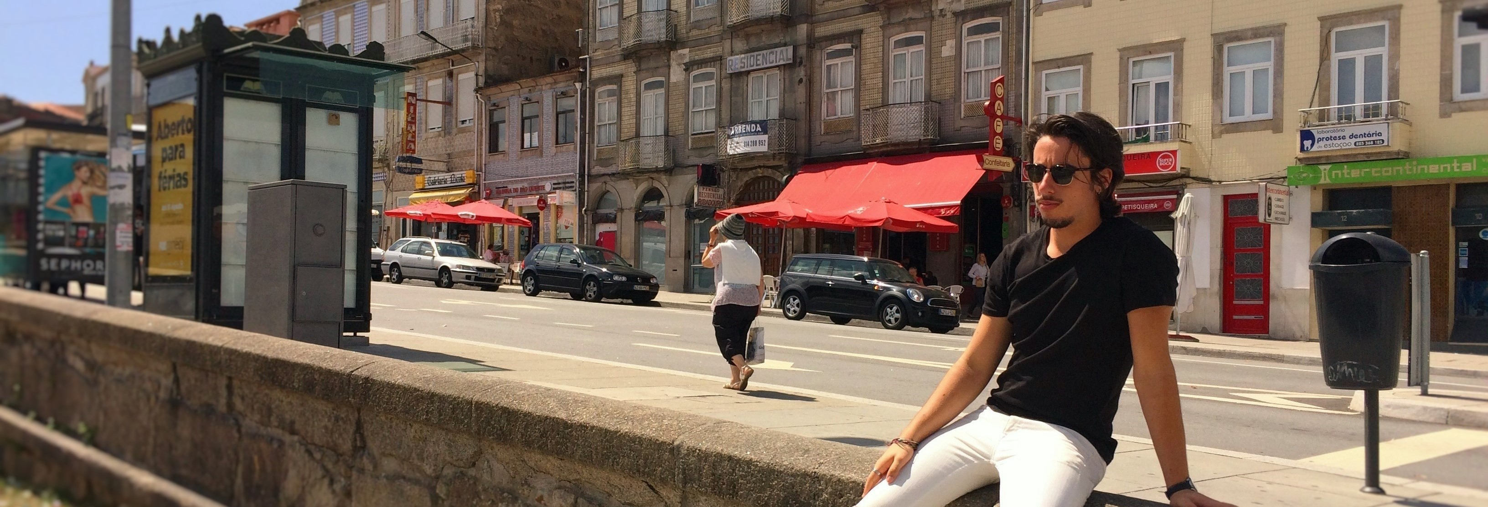

Let me ask you something. Imagine you are trying to solve a mathematical problem and it is given to you two options:

Option 1: you can solve it by using only half of your brain capabilities.

Option 2: you can solve it using the totality of your brain's power, but you have to learn a few simple concepts beforehand.

You would most likely choose Option 2, right?

If you didn’t have to learn too much to be able to use your brain's full capacity you would probably go that route.

What if I told you that you are not using 100% of your reading capabilities when interacting with people?

Surprisingly enough, most people are in that category, being clueless of what other people are thinking.

**What You'll Learn**

So, in this article I am going to show you:

* **Why and How Important** is it for the younger generation to learn body language (ex: high school or university graduates)
* The **One Simple Method** I use to read people
* 2 **Body Language Mistakes** to Avoid

I want to share this information with everyone to not only be able to help them read people but also improve their own image. That is the mission of my website [www.simplebodylanguage.com](http://www.simplebodylanguage.com).

**Reality and Benefits of the World of Body Language**

Nowadays, after graduating from high school, college or university, it's harder than ever to get a job, and learned skills is what differentiates us from the next guy/girl, when applying for a job.

Although being able to read people is not actually something you can get a certificate for, it will help you reach a new level of communication with other humans.

Let's see a few applicable benefits of learning Body Language:

* You'll become more charismatic
* You'll learn social cues, thus having better conversations
* You'll be able to know what somebody is thinking

Let's see a few examples of where you could benefit from knowing body language and non-verbal communication.

**Example 1: New Friends?**

Imagine yourself in a bar and you just met a group of people. It seems to you that they like you and want to keep talking to you.



However, they are actually thinking that they do not want to talk to you and you are not wanted in the group. You didn't catch their intentions because you were obliviant to their body language signs, creating a bad impression.

**Example 2: Entrepreneurship**



You are an entrepreneur, you just had an amazing idea but you need funding and decide to schedule a meeting with a couple of angel investors.

You start your pitch, and in the beginning they are hooked and interested.

However, after some time they start to think about different stuff because your product does not interest them or there is something you did that turned them off.

How are you going to know what they were thinking if you can't read body language and assess what your next move should be?

Knowing how to read people will help you understand when you should back off or keep selling and close the deal based on their reactions.

**Example 3: Love at First Sight**



Another example would be when you are somewhere and you see a girl/guy you are interested in and you want to know if your advances would be well received.

If you were able to read the person and check for availability/invitational signs you would be on your way to getting his/her phone number.

**Example 4: Applying for a Job**

Last but not least, when you are applying for a job. The most important part of a job interview is how you present yourself to the employer.



The clothes that you choose to dress, the way you walk, speak and the kind of vibes you send out all matter in creating the best first impression.

Think about your last job interview. Do you think you looked confident, needy or afraid?

By learning body language you can understand how to change your behavioral gestures in order to display a certain image of yourself, hopefully increasing the chances of being hired.

**How do I start reading people?**

Deep down, in our subconscious, we all know how to read body language. It's something we call *instincts*.

And that is what I want to bring out of you today.

So, how do you actually use your instincts to read people? With the BASELINE METHOD!

In essence, it's something quite simple, but it works, because it's based on the principle of comparison.

Think about the last time you met somebody. What can you actually recall from the interaction? That they were nice? What their name was?

That's a good start, but I invite you to consider this step by step process:

**The Baseline Method**

**Step 1. Meeting the person**

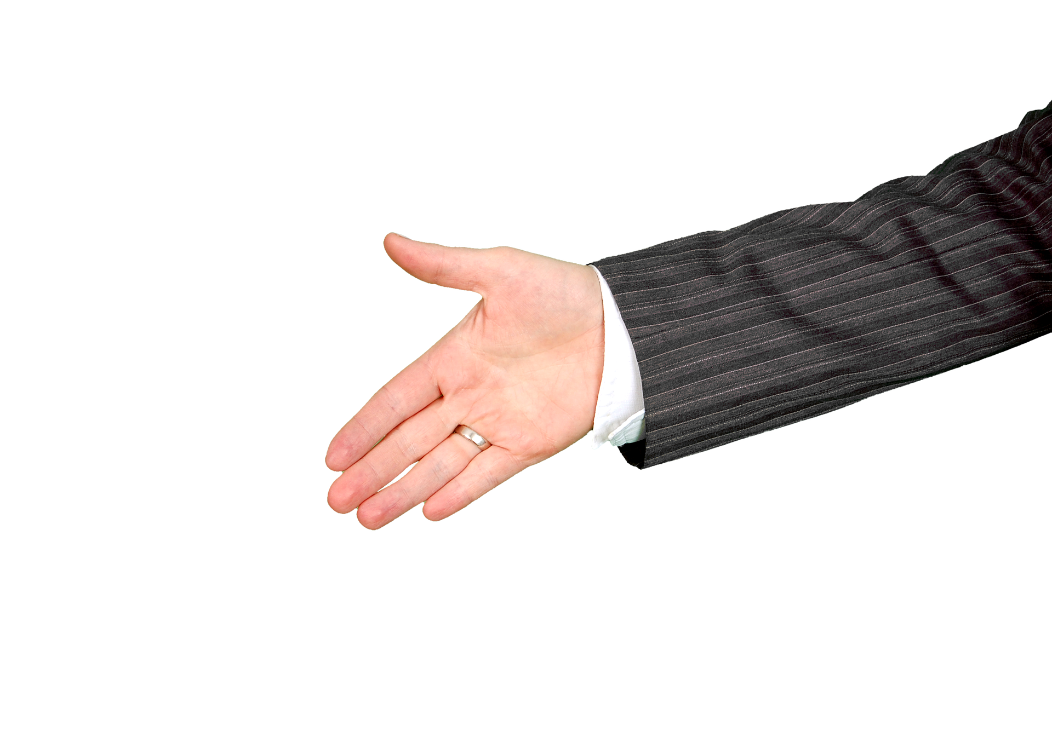

As soon as you meet somebody you should start examining their body language, like:

* Their Handshake **(http handshake)**
* Their Eye Contact
* Their Posture

**Step 2. First Interaction**

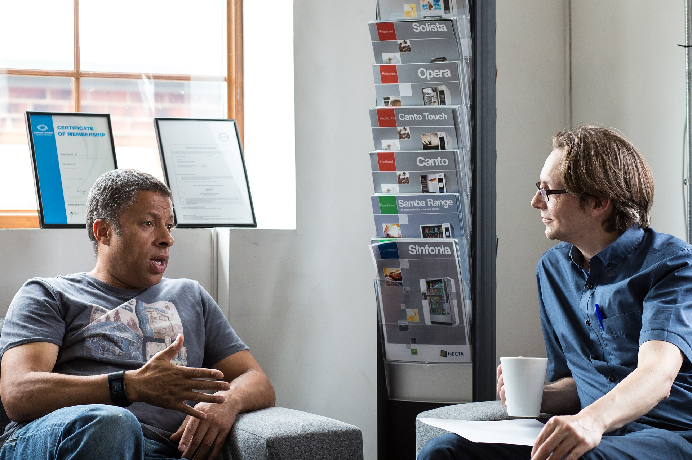

As you start talking to them, ask them questions and try to get to know their background story and what they do for a living.

*Tip: Focus on questions that the person doesn't have a reason to lie or get uncomfortable.*

Your objective in this step is to:

* Establish a baseline of normal body language of the person in order to understand what their typical behavior looks like

**Step 3. Compare Behaviors**

Now that you have the normal behavior of the person, you have to watch for changes in body language signs.

The easiest way to see a difference is to notice when somebody gets uncomfortable after something happens or is said.

**Example 1:**

You are talking to somebody and you're telling them a story, and at first they are very interested, with their whole body towards you.

However, after a while, they lose interest in the story and their body starts to point in another direction, away from you (best indicator: feet direction).

This is a change from their typical behavior that you should look out for. Resolve this issue by immediately asking them a question and let them talk.

**Example 2:**

If you look at somebody's smile you can also see when it goes from genuine to fake.

Here are two photos that show the difference.

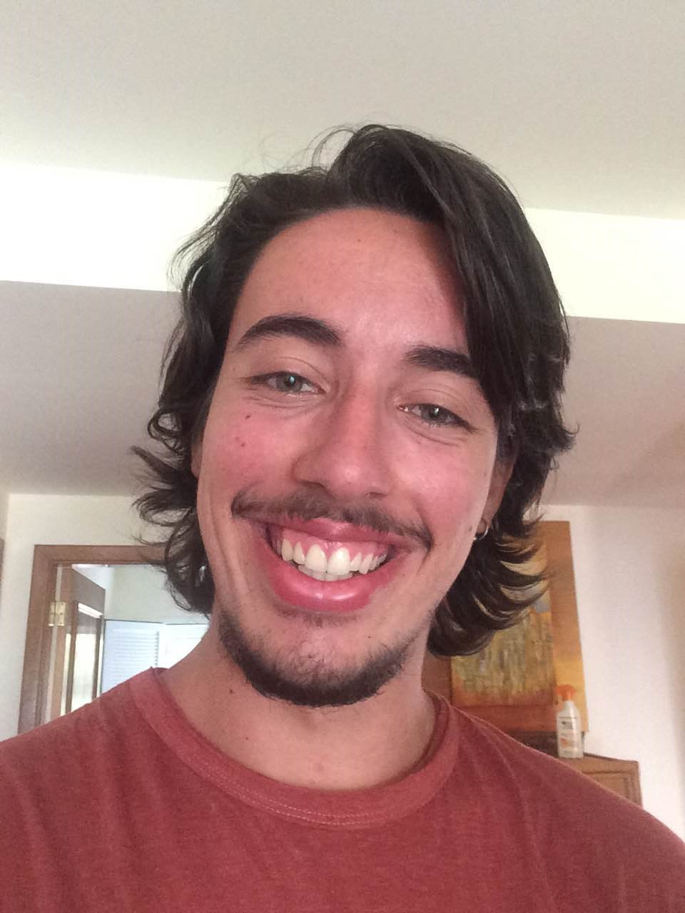

Genuine Smile

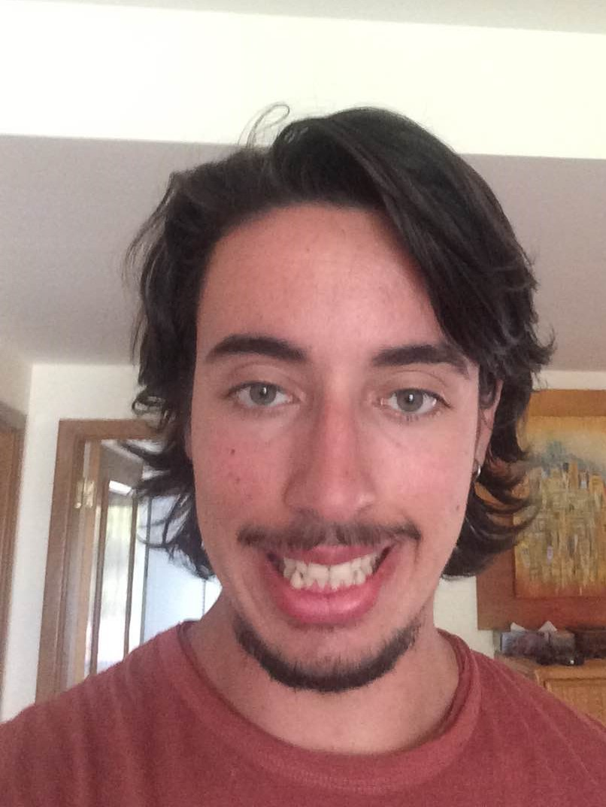

Fake Smile

This is the typical transition you can spot when the person you are talking to goes from a genuine to a fake smile.

Check out this link to learn how to spot the difference between the Genuine and Fake Smile **(http Genuine vs Fake).**

**Avoid these Mistakes for Success**

We all want to give the best impressions, but sometimes we don't know how.

So, here are two mistakes I recommend you to avoid and fix, to improve your overall image:

* Bad Posture
* Closed Positions

**Bad Posture**

Nowadays we see more and more people with a horrible posture walking down the street, and I think it is mostly due to two reasons:

* Time spent seated
* Time spent hunching over phones

Unfortunately, these are very common in our society. But I have a few solutions:

* Try to work standing up, or take frequent breaks to walk around
* Spend less time in your phone
* Exercise

If you like to correct your posture overall I invite to check out this link where there is information on how to fix it plus other mistakes to avoid **(http free course)**.

**Closed Positions**

This is quite a simple concept to understand but you have to be very diligent with yourself in order to fix it.

Basically, the objective is to avoid closed off positions like these:

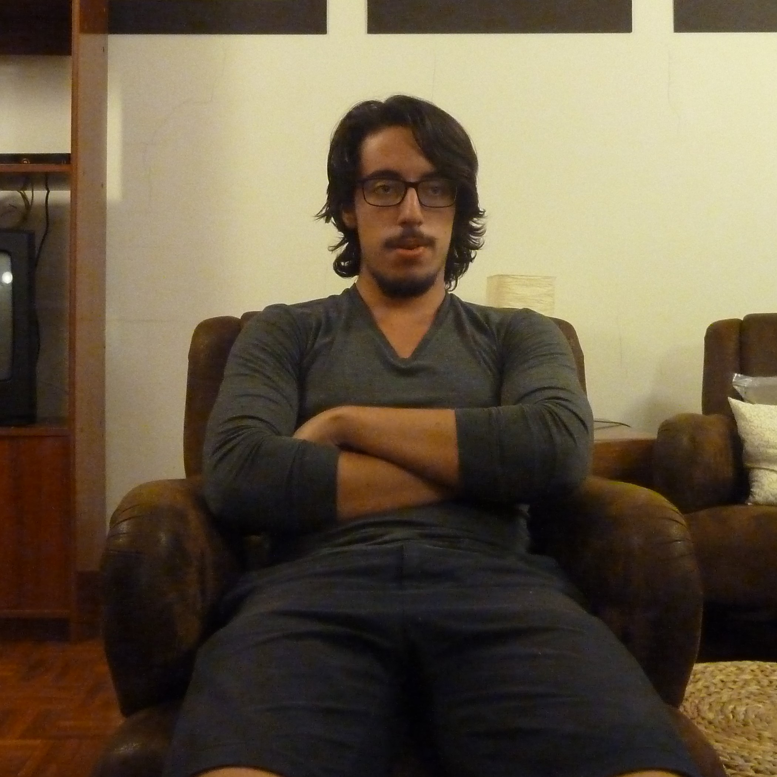



And instead use these positions:

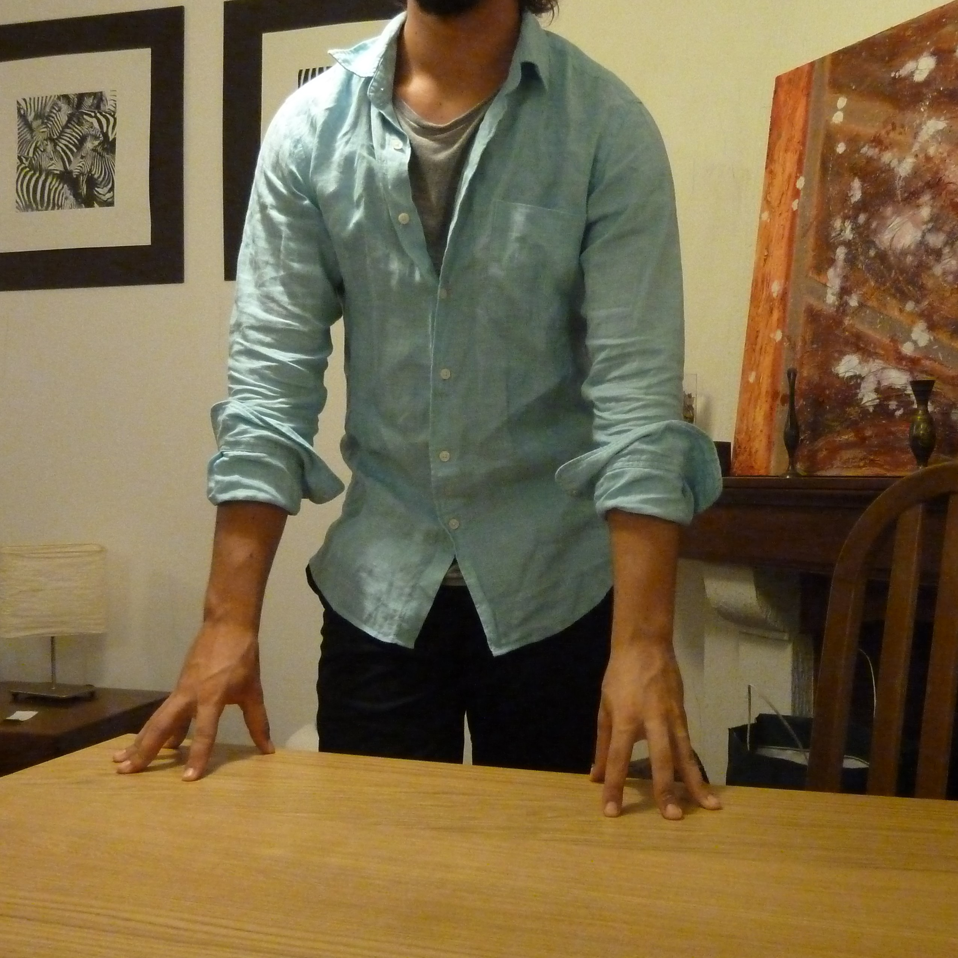

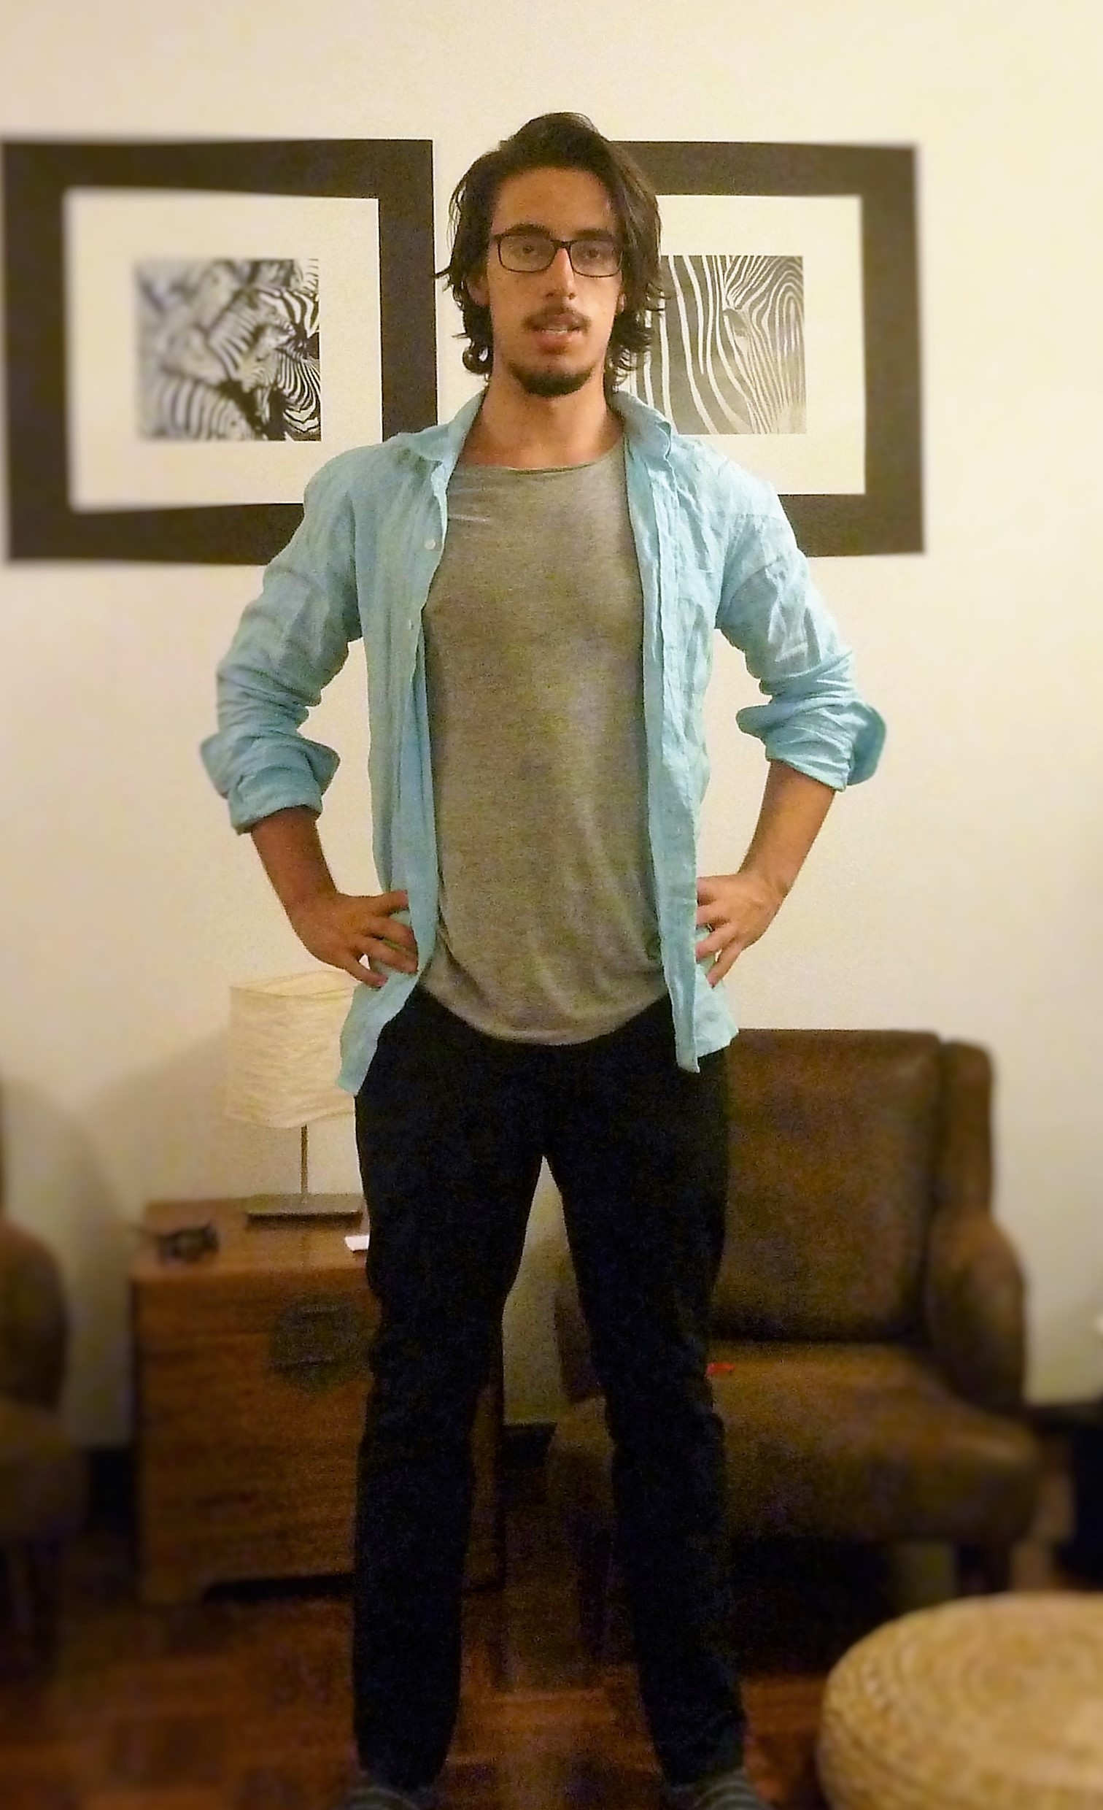

When you adopt open body positions you'll feel and look more open minded and confident.

**How to Read Body Language**

Now that I have presented you with:

* All the Reasons to Learn Body Language
* The Baseline Method
* The Two Mistakes to Avoid

I invite you to join this path **(http://simplebodylanguage.com/get-updates/)** with me, in a mission to better ourselves each and every day.

Check out the rest of the 11 mistakes you should avoid in my free course or come to [www.simplebodylanguage.com](http://www.simplebodylanguage.com) to visit us.

Hope you enjoyed this article and make sure to state your opinion in the comments and join the discussion.

Carpe Diem,

Guido